Doencas infeciosas

Download Universal Android Tool MTK Qualcomm Latest | ACT Unlock Tool Pro V3.0 Full With Loader
Last Updated on: March 11, 2023 by Admin
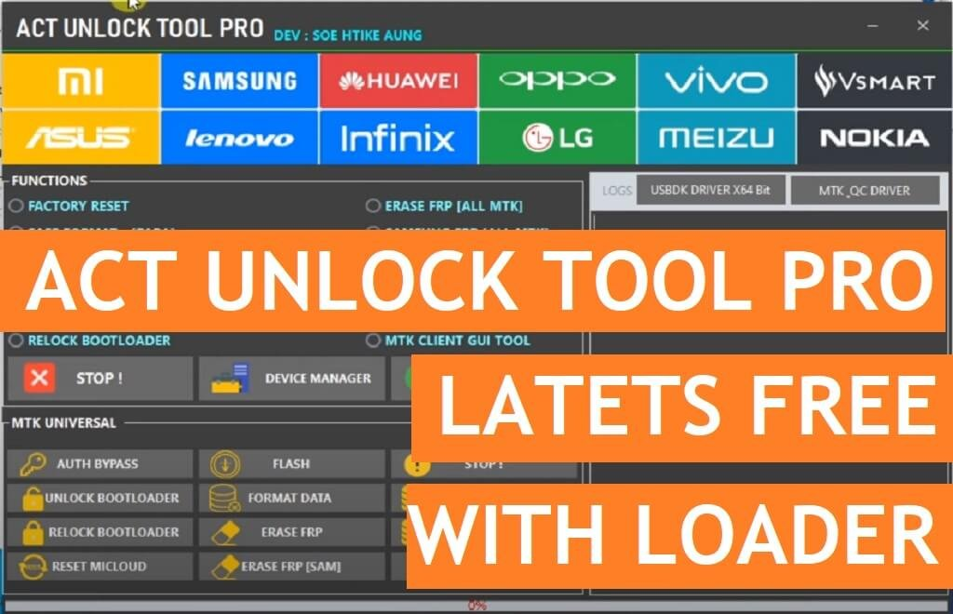
ACT Unlock Tool 3.0 is a simple Universal mobile repair software that supports MTK, and Qualcomm-powered phones and allows users to Erase FRP, Remove Pattern Password Pin, Format, Factory Reset, Erase Vivo Demo mode, unlock Bootloader, unlock Mi lock, bypass SLA DAA, easily through Flash/MTP/USB VCOM/EDL/Qcom modes.
Contents hide
Download ACT Unlock Tool V3.0 Universal Android MTK Qualcomm Latest
How to Use ACT Unlock Tool V3.0 Full With Loader
The procedure for using the Adanichell Universal Android Tool MTK Qualcomm is quite simple, just run the FRP Tool, and connect your device in MTP/Flash/EDL USB Mode, Now Select the desired option you want to use, now it will detect and unlock your phone. But, first, You have to install a proper USB driver on your PC.
So, If you want to feel the premium software for free then download Universal Android MTK Qualcomm ACT Unlock Tool Pro V3.0 Full With Loader Latest version and follow our instructions to fix the phone.
More: Xiaomi Bootloader Tool | Xiaomi MTK Bootloader Unlock Relock Free Latest (Unofficial)

Download ACT Unlock Tool V3.0 Universal Android MTK Qualcomm Latest
Now check the below link to download the latest version of the ACT Unlock Tool Pro V3.0 Full With Loader to your computer for free. It is exclusively available only for the Windows 64bit platform.
File Name: ACTUnlockProV3.zip
File Size: 300MB
Type:.exe
Compatible OS: Windows XP (32bit), Windows 7 (32bit & 64bit), Windows 8 (32bit & 64bit), Windows 8.1 (32bit & 64bit), Windows 10, Windows 11 (32bit & 64bit)
Credit: Soe Htike Aung [Loader Credit: *]
Download: ACTProTool.zip [Setup password: act1] [Activation key: SahirlTecno]

How to Use ACT Unlock Tool V3.0 Full With Loader
- Download & extract the ACT Unlock Tool Pro setup to your Computer.
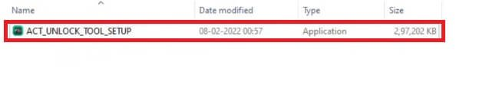
- Now Run Setup ACT_Unlock_Tool_Setup.exe as Administrator.
- It will ask you a password, type: act1
- Wait for a few Sec to open the tool.
- Now install the tool
- Follow the on-screen instructions to completely install the tool on your PC
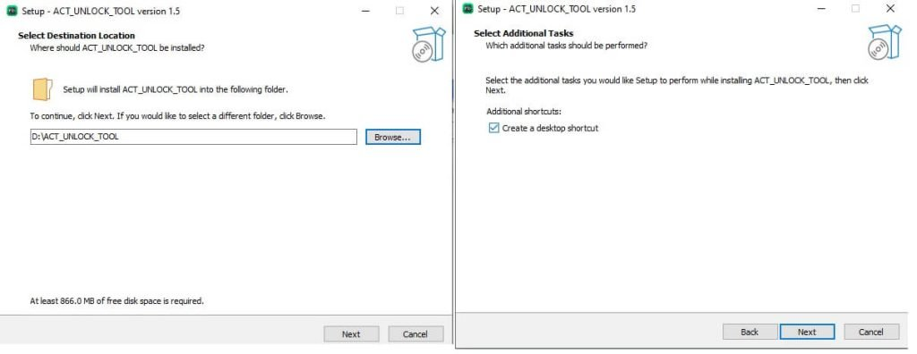
- Click Next => Tick on Create a desktop shortcut
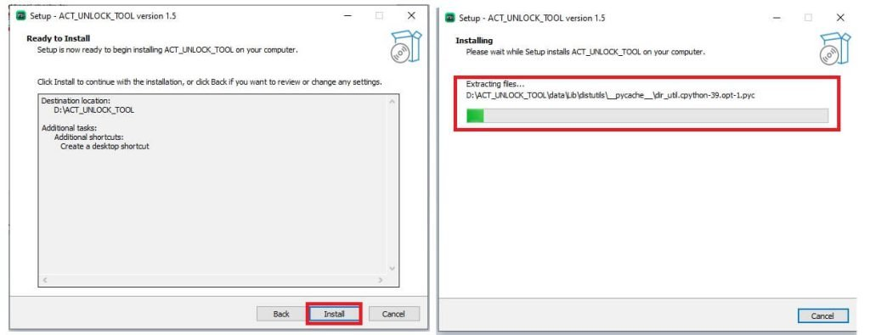
- Now Select the Installation Directory => Tap Install
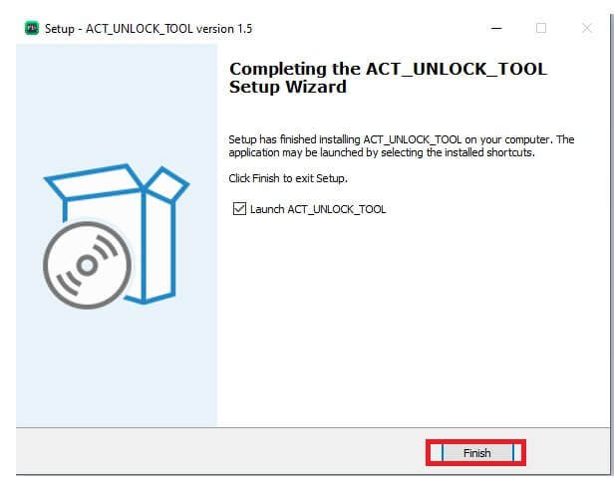
- Then Tick on Launch ACT Unlock Tool Pro =>> Tap Finish
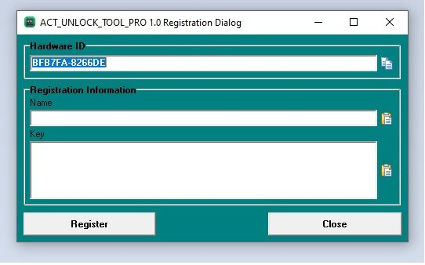
- Now the Tool will open and ask you to register the tool
  - Put Key: SahirlTecno
- Extract the ACT Tool Full Loader File
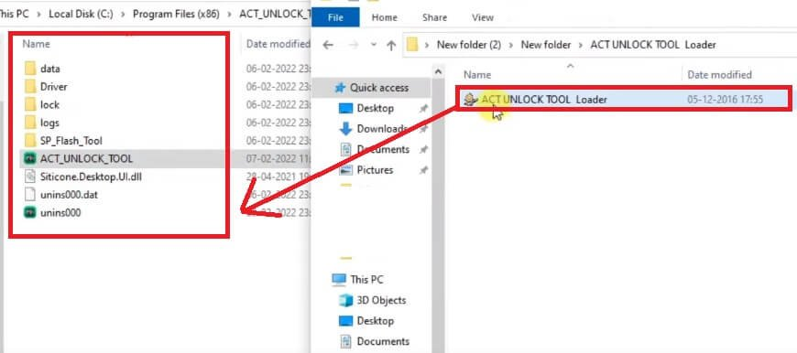
- Copy & Paste the ACT Pro Loader File to your ACT installation folder
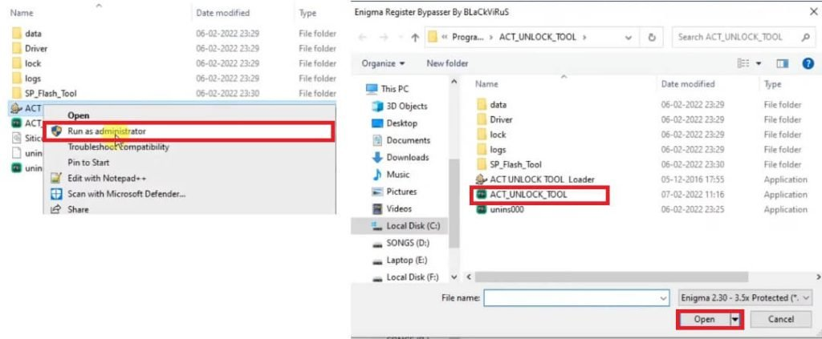
- Now Run the ACT Loader File as Admin
- A Window will Open, select the ACT_Unlock_tool.exe and Tap Open
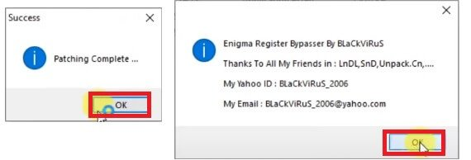
- Now, a Success “Patching Complete” Pop-up box will appear, Tap OK => Ok.
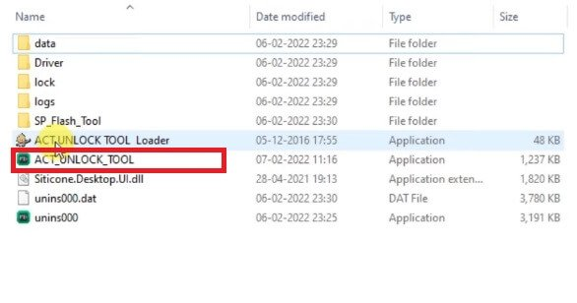
- Run the ACT_Unlock_Tool.exe As Admin
- The Tool will open on your PC
- You will get the below listed option
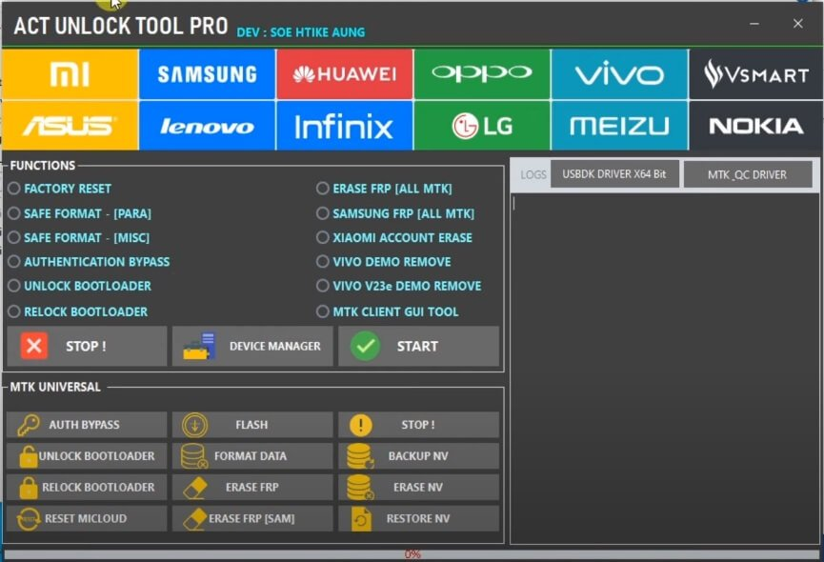
- Functions:
  - Factory Reset || Erase FRP [All MTK]
  - Safe Format- [PARA] || Samsung FRP [All MTK]
  - Safe Format – [Misc] || Xiaomi Account Erase
  - Authentication Bypass || Vivo Demo Remove
  - Unlock Bootloader || Vivo V23e Demo Remove
  - Relock Bootloader || MTK Client GUI Tool
- MTK Universal:
  - Auth Bypass || Flash || Stop
  - Unlock Bootloader || Format Data || Backup NV
  - Relock Bootloader || Erase FRP || Erase NV
  - Reset MICloud || Erase FRP [SAM] || Restore NV
- USBDK Driver X64 Bit || MTK QC Driver
- Now Power Off your Android Phone
- Put it into the EDL, VCOM, Preloader, Flash, Meta, mode
- Connect your phone to the PC
- Choose the function you want to use on the tool
- That’s it.
Read More: MP Service Module Tools V1.0.3 MediaTek MTK & Qualcomm AIO Tool Free Download
CategoriesDownload Android Tools
Share on:

Related Posts
Nut Pro Tool V1.0.4 Download Latest Version Free
VG SPD Factory Reset Tool Download Latest [Spreadturm Pattern Unlock]
Maui Meta Tool v10.1816 Download Latest Version (All Setup) Free
OMH Advanced Xiaomi Tool Pro V2.1 Download Latest Version Free
XAF OTA Disable Tool By SHA for Xiaomi, Oppo, Vivo, OnePlus
OMH OTA Disabler Tool V1.0 Download Latest Version Free
Borneo Knox Erase Tool v1.6.4 Download [Latest Version] Free
ZeroKnox Removal Tool V1.5 Download Latest Version Update Free

